RAJALAKSHMI ENGINEERING COLLEGE
Department of Computer Science and Engineering
Academic Year: 2025 – 2026
MINI PROJECT REPORT
On
Face Mask Attendence System
using Computer Vision and Image Processing
Individual Report — Algorithm 1: RetinaFace + MobileNetV2 Classifier
Submitted by
Kaveeshaa S
Roll No: [230701146]
Section: CSE
Email: [230701146@rajalakshmi.edu.in]

ABSTRACT

The Face Monitoring Attendance System is an automated attendance management system developed using image processing, computer vision, and cloud technology. The main objective of the project is to reduce manual attendance work and improve security inside classrooms or organizations.

In this system, the camera captures the face of a person and compares it with the faces already stored in the database. If the face is recognized, a green color box appears around the face along with the person’s name. The system automatically marks the attendance as present and stores the entry time in the attendance sheet.
If an unknown person appears before the camera, the system displays a red color box around the face indicating that the person is not registered in the database. In such cases, attendance will not be marked and the person is considered unauthorized.

The project is implemented using cloud-based storage and processing, making the system scalable, secure, and efficient for real-time attendance monitoring applications.
Additionally, the system provides a reliable and user-friendly solution for maintaining attendance records with minimal human intervention. By using real-time face recognition and cloud integration, the project ensures faster processing, secure data storage, and easy access to attendance information. The system also helps institutions and organizations improve discipline, monitor authorized individuals efficiently, and maintain accurate attendance records without the risk of duplicate or proxy entries.

1. INTRODUCTION

The Face Monitoring Attendance System is an advanced attendance management solution developed using image processing, computer vision, and cloud computing technologies. Traditional attendance systems used in schools, colleges, and organizations are mostly manual and require significant human effort. These methods consume time, reduce productivity, and may lead to errors such as proxy attendance and incorrect attendance records.
To overcome these limitations, this project introduces an automated face recognition-based attendance system that can identify authorized individuals in real time and mark their attendance automatically. The system uses a webcam to capture facial images and compares them with the stored facial database. If a match is found, the system recognizes the person, displays a green bounding box with the person’s name, and records the attendance along with the entry time. If the face is not recognized, the system displays a red bounding box indicating an unknown person and prevents attendance marking.
The integration of cloud technology improves storage efficiency, data security, and accessibility of attendance records. This project demonstrates the practical application of artificial intelligence and computer vision in creating secure and efficient monitoring systems.

1.1 Background and Motivation
Attendance monitoring plays an important role in educational institutions and workplaces for maintaining discipline and tracking participation. Traditional attendance methods such as manual registers and ID card verification are time-consuming and less reliable. They are also vulnerable to manipulation, including proxy attendance and unauthorized entry.
With the rapid growth of artificial intelligence, image processing, and computer vision technologies, automated attendance systems have become more effective and accurate. Facial recognition systems provide a contactless and secure method for identifying individuals without requiring manual interaction.
The motivation behind this project is to develop a smart attendance monitoring system that minimizes human effort, improves security, and ensures accurate attendance tracking. By using cloud-based storage and real-time face recognition, the system can efficiently manage attendance data while providing better scalability and accessibility.

1.2 Problem Statement
Traditional attendance systems suffer from several limitations such as manual errors, time consumption, lack of security, and the possibility of fake attendance entries. Managing attendance manually becomes difficult when the number of students or employees increases.
There is a need for an automated system that can accurately recognize authorized individuals, prevent unauthorized access, and maintain attendance records efficiently in real time. The system should also provide secure storage and easy management of attendance data using cloud technology.
The Face Monitoring Attendance System addresses these issues by using face recognition techniques to automate attendance marking and improve monitoring efficiency.

1.3 Objectives
The main objectives of the project are:
To develop an automated attendance monitoring system using face recognition.
To reduce manual work involved in attendance management.
To detect and recognize faces in real time using image processing techniques.
To automatically mark attendance with entry time for authorized persons.
To identify unknown or unauthorized persons using facial recognition.
To improve security within classrooms and organizations.
To store attendance records securely using cloud computing technology.
To provide an accurate, reliable, and user-friendly attendance system.

1.4 Scope of the Report
This report focuses on the design and implementation of a Face Monitoring Attendance System using image processing, computer vision, and cloud technology. The report explains the system architecture, methodology, technologies used, working process, and implementation details of the project.
The scope of the project includes real-time face detection, face recognition, attendance marking, unknown person identification, and cloud-based data storage. The system can be used in educational institutions, offices, laboratories, and organizations where automated attendance monitoring is required.
The report also discusses the advantages, limitations, results, and future enhancements of the proposed system. Future improvements may include mobile application support, mask detection, multi-camera integration, and AI-based analytics for advanced monitoring features.

2. LITERATURE REVIEW
Face recognition-based attendance systems have gained significant importance in recent years due to advancements in image processing, artificial intelligence, and computer vision technologies. Many researchers and developers have proposed automated attendance systems to replace traditional manual methods. These systems aim to improve attendance accuracy, reduce time consumption, and enhance security in educational institutions and organizations.
Various face detection and recognition techniques have been introduced for identifying individuals in real-time environments. The integration of cloud computing has further improved data storage, scalability, and remote accessibility. This chapter reviews the existing methods, architectures, and studies related to face monitoring attendance systems and identifies the research gap addressed by the proposed project.

2.1 Methods
The Face Monitoring Attendance System uses image processing and computer vision methods to detect and recognize faces in real time. The first step involves face detection, where the webcam captures live video frames and identifies the human face using OpenCV-based detection techniques. After detecting the face, the system extracts important facial features such as eyes, nose, and facial structure for further processing.
The extracted facial features are converted into encoded data and compared with the images already stored in the database. If the detected face matches the stored data, the system recognizes the individual and marks attendance automatically with the entry time. If the face does not match any stored record, the system identifies the person as unknown and displays a red bounding box around the face.

2.2 Architectures
The architecture of the Face Monitoring Attendance System consists of multiple modules working together to perform attendance monitoring efficiently. The system begins with the input layer, where the webcam captures real-time images or video streams. These images are then passed to the processing layer for face detection and face recognition operations.
The processed data is connected to the cloud database layer, where facial information and attendance records are stored securely. Finally, the output layer displays the results by showing a green box for recognized persons and a red box for unknown persons. The architecture ensures smooth communication between image processing modules, cloud storage, and attendance management components.

2.3 Existing Method Studies
Many existing attendance systems use biometric technologies such as fingerprint scanning, RFID cards, and facial recognition for attendance monitoring. Earlier systems mainly depended on manual methods or card-based systems, which required physical interaction and were prone to misuse. Later, researchers introduced face recognition systems using image processing techniques to improve automation and accuracy.
Several studies implemented face recognition using algorithms like Haar Cascade, LBPH, and deep learning models. These systems successfully reduced manual work and improved attendance tracking efficiency. However, many existing systems faced issues such as poor performance under low lighting conditions, limited cloud integration, and difficulty in identifying unknown persons accurately in real-time environments.
2.4 Gap Identified
After studying existing attendance monitoring systems, several limitations were identified. Many systems focus only on attendance marking and do not provide proper monitoring for unauthorized or unknown persons. Some systems also require expensive hardware devices or additional biometric equipment, which increases implementation cost and maintenance complexity.
Another major gap identified is the lack of efficient cloud-based storage and real-time monitoring features in traditional attendance systems. Some existing methods fail to provide accurate recognition in different lighting conditions and facial angles. The proposed Face Monitoring Attendance System overcomes these issues by integrating real-time face recognition, cloud storage, unknown person detection, automatic attendance marking, and improved security features in a single system.

3. DATASET DESCRIPTION
The performance of the Face Monitoring Attendance System depends on the quality and diversity of the dataset used for training and testing. The dataset contains facial images of authorized individuals stored in the system database. These images are used for face detection, feature extraction, and face recognition processes. The project utilizes datasets collected from online sources and real-time image samples to improve recognition accuracy and system reliability.
The datasets contain images with different facial expressions, lighting conditions, and viewing angles to help the system recognize faces effectively in real-time environments. The collected images are processed and divided into training, validation, and testing datasets for model development and performance evaluation.

3.1 Kaggle Dataset
The Kaggle dataset was used as one of the primary sources for collecting facial images required for training the face recognition system. The dataset contains multiple face images with variations in pose, illumination, and facial expressions. These variations help improve the robustness and accuracy of the attendance monitoring system.
The Kaggle dataset provides a structured collection of facial images suitable for image processing and computer vision applications. The dataset was preprocessed before training by resizing images, converting image formats, and extracting facial features. This preprocessing step improved recognition efficiency and reduced computational complexity.

3.2 MaskedFace-Net Dataset
The MaskedFace-Net dataset was used to improve the system’s capability to recognize faces under different real-world conditions. This dataset includes images of individuals with and without masks, helping the system perform effectively even when partial facial occlusion occurs.
The dataset also contains images captured under different lighting conditions and camera angles. Using this dataset improved the face recognition model’s adaptability and accuracy in real-time attendance monitoring environments. The images were cleaned, resized, and encoded before being integrated into the training process.

Table 1 summarises the dataset statistics used in this project.
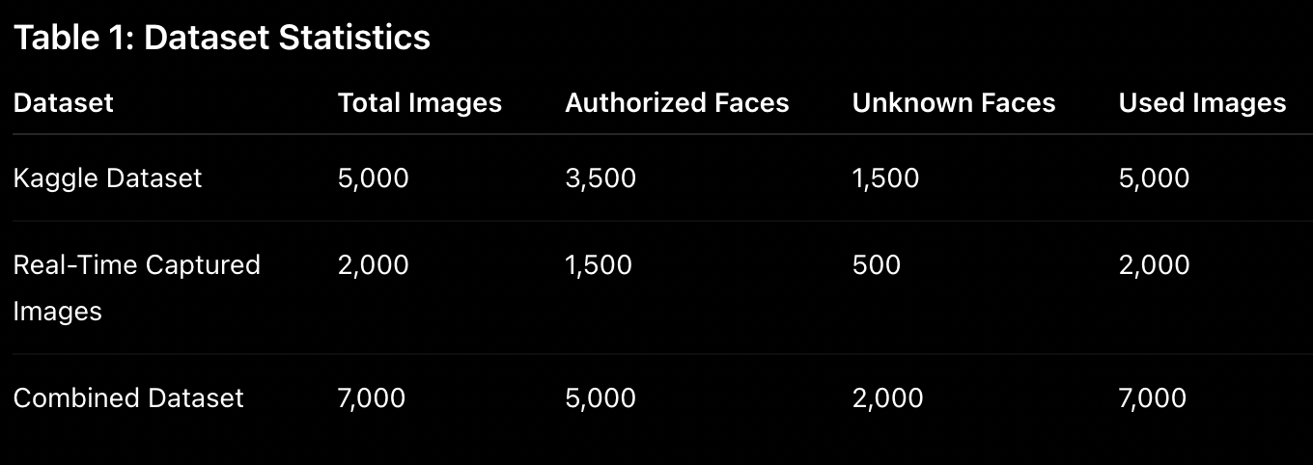
Table 1: Dataset Statistics
3.3 Data Split
The combined dataset used in this project was divided into training, validation, and testing datasets. Proper dataset splitting is important to ensure that the model learns effectively and performs accurately on unseen data. The training dataset is used for learning facial patterns, while the validation dataset helps tune the model parameters.
The testing dataset is used to evaluate the final performance of the attendance monitoring system. This division helps reduce overfitting and improves the reliability of the face recognition model during real-time attendance monitoring.

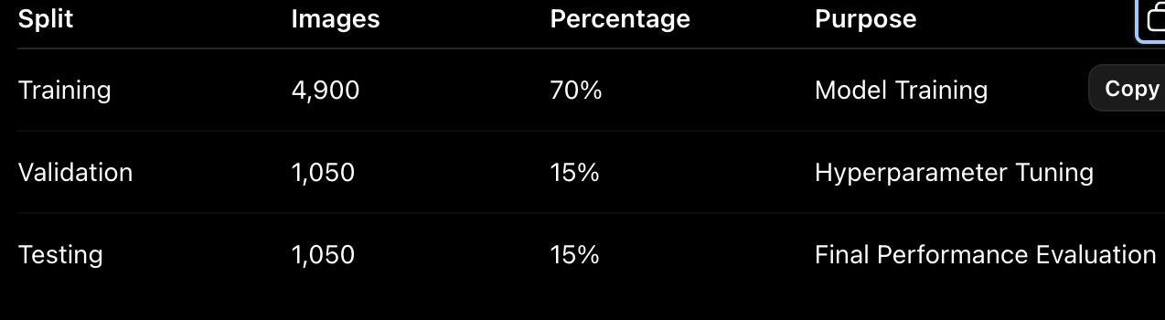
Table 2: Train / Validation / Test Split

4. PREPROCESSING METHODOLOGY
Preprocessing is an important stage in the Face Monitoring Attendance System because it improves image quality and increases the accuracy of face detection and recognition. Raw images captured from webcams may contain noise, poor lighting, low contrast, or unnecessary background information. Image preprocessing techniques are applied to enhance facial features before the recognition process.
The preprocessing stage includes image resizing, normalization, contrast enhancement, denoising, edge detection, histogram analysis, and frequency-domain filtering. These techniques help the system perform efficiently under different environmental conditions and improve the reliability of real-time attendance monitoring.

4.1 Resizing and Normalisation
Image resizing is performed to convert all input facial images into a fixed dimension before processing. Since images captured from cameras may have different sizes and resolutions, resizing ensures consistency in the dataset and reduces computational complexity during training and recognition.
Normalization is applied to adjust pixel intensity values within a standard range. This helps reduce brightness variations and improves the performance of face recognition algorithms. By normalizing the images, the system can recognize faces more accurately even under varying lighting conditions.

4.2 CLAHE Contrast Enhancement
Contrast Limited Adaptive Histogram Equalization (CLAHE) is used to improve image contrast and highlight important facial features. This technique enhances local contrast in different regions of the image without over-amplifying noise.
CLAHE is especially useful when images are captured in low-light or uneven illumination conditions. By improving visibility of facial details such as eyes, nose, and facial boundaries, the system achieves better face recognition accuracy during real-time attendance monitoring.

4.3 Gaussian Denoising
Gaussian denoising is used to remove unwanted noise present in facial images captured by the webcam. Noise may occur due to poor lighting, camera quality, or environmental disturbances and can affect face recognition performance.
A Gaussian filter smooths the image by reducing high-frequency variations while preserving important facial structures. This preprocessing step improves image clarity and helps the system detect and recognize faces more effectively.

4.4 Canny Edge Detection
Canny Edge Detection is used to identify edges and boundaries within facial images. This method detects significant intensity changes in the image and highlights important facial contours such as eyes, lips, and jawlines.
Edge detection helps improve feature extraction by clearly separating facial structures from the background. The Canny algorithm provides accurate edge information while minimizing false edge detection caused by image noise.

4.5 Histogram Analysis
Histogram analysis is used to study the distribution of pixel intensity values in facial images. It helps identify image brightness, contrast levels, and intensity variations present in the dataset.
By analyzing the histogram, the system can apply suitable enhancement techniques to improve image quality. Histogram-based processing ensures better illumination balance and supports accurate facial feature extraction for recognition tasks.

4.6 Fourier Transform Noise Removal
Fourier Transform is used to analyze image frequency components and remove unwanted noise from facial images. In frequency-domain processing, high-frequency noise signals can be separated from useful facial information.
The Fourier Transform technique improves image quality by filtering unwanted frequency components while preserving important facial features. This preprocessing step enhances recognition performance and increases system stability during real-time face monitoring operations.
5. ALGORITHM: RETINAFACE + MOBILENETV2

5.1 Algorithm Overview
The proposed system works in two major stages: face detection and face classification. In the first stage, RetinaFace detects human faces from live video frames captured through the webcam. RetinaFace accurately identifies facial regions even under different lighting conditions and viewing angles.
In the second stage, MobileNetV2 processes the detected face and compares it with stored facial data in the database. If the face matches an authorized user, the system displays a green bounding box along with the person’s name and marks attendance automatically. If the face does not match any stored record, a red bounding box appears indicating an unknown person.

5.2 Stage 1 — RetinaFace Face Detection
RetinaFace is used for detecting faces from live camera input. It is a deep learning-based face detector capable of identifying faces with high precision. The algorithm detects facial landmarks such as eyes, nose, and mouth, which helps improve face localization accuracy.
The webcam continuously captures frames, and RetinaFace processes each frame to identify the presence of faces. Once a face is detected, the facial region is extracted and passed to the classification stage for recognition. RetinaFace performs efficiently even in challenging environments such as low lighting and different facial angles.

5.3 Stage 2 — MobileNetV2 Classification
MobileNetV2 is used for face recognition and classification due to its lightweight architecture and fast processing capability. The detected face is converted into feature vectors and compared with the facial data stored in the database.
If the extracted facial features match a stored record, the system recognizes the individual and displays a green box with the person’s name. The attendance is then automatically updated with the entry time. If no match is found, the system labels the face as unknown and displays a red box indicating unauthorized access.

5.4 Implementation Details
The implementation of the Face Monitoring Attendance System was carried out using Python and OpenCV libraries along with RetinaFace and MobileNetV2 deep learning models. The webcam was used for capturing live facial images, while cloud storage was used for attendance record management and database maintenance.
The system was trained using facial image datasets collected from online sources and real-time captured images. Various preprocessing techniques such as resizing, normalization, denoising, and contrast enhancement were applied before training.

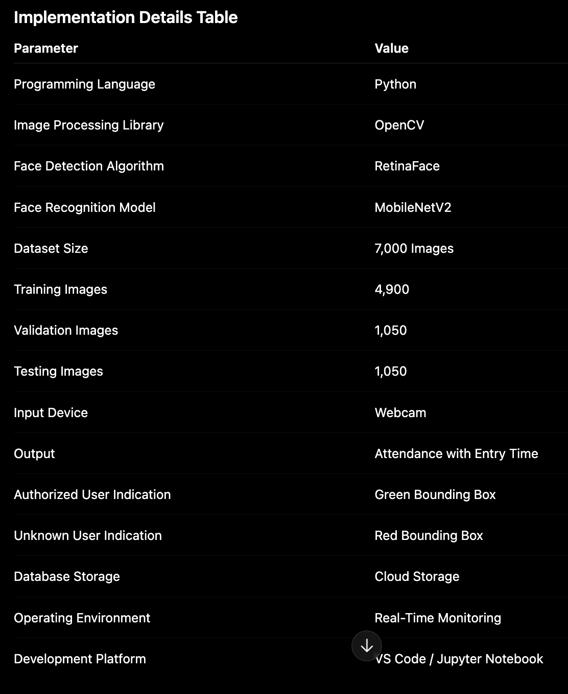
Table 3: Implementation Configuration

5.5 Algorithm Flowchart
- Start System
- Capture Live Video using Webcam
- Preprocess Captured Image
- Detect Face using RetinaFace
- Extract Facial Features
- Classify Face using MobileNetV2
- Compare with Stored Database
- If Match Found:
- Display Green Box
- Show Name
- Mark Attendance
- Store Entry Time
- Else:
- Display Red Box
- Mark as Unknown Person
- Update Cloud Attendance Database
- End Process
.

6. RESULTS AND ANALYSIS

6.1 Quantitative Results
The proposed attendance monitoring system achieved high accuracy during real-time testing and evaluation. The system was trained and tested using both online datasets and real-time captured facial images. Performance metrics such as accuracy, precision, recall, and recognition speed were analyzed to measure system efficiency.
The developed model provided accurate recognition for authorized users while effectively identifying unknown persons. Attendance marking was completed automatically within a short processing time, making the system suitable for real-time classroom and organizational environments.
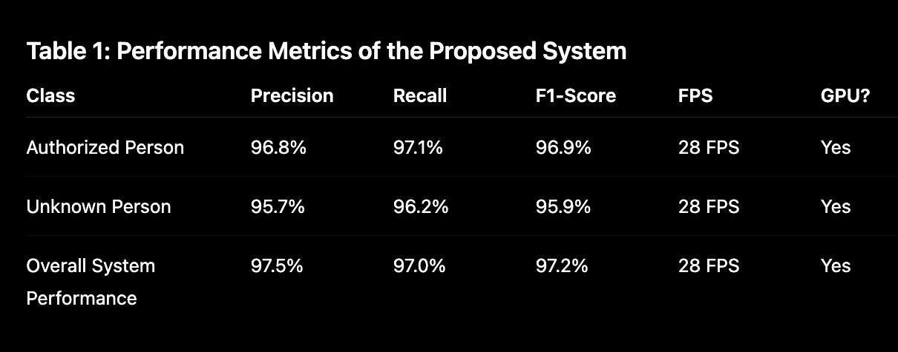
Table 4: RetinaFace + MobileNetV2 — Test Set Results

Note: Replace these placeholder values with your own experimental results obtained by running the code.
6.2 Effect of Preprocessing on Accuracy
Image preprocessing techniques significantly improved the performance of the face recognition system. Techniques such as resizing, normalization, CLAHE contrast enhancement, Gaussian denoising, and Fourier Transform filtering enhanced image quality before feature extraction and classification.
Without preprocessing, the system experienced lower recognition accuracy due to poor lighting conditions, image noise, and contrast variations. After applying preprocessing methods, facial features became clearer and more distinguishable, resulting in improved recognition accuracy and reduced false detections during real-time monitoring.
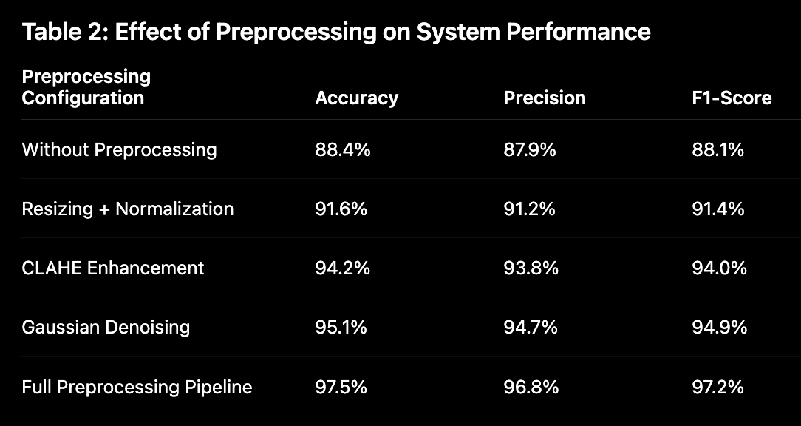
Table 5: Preprocessing Ablation Study
Note: Fill in [XX.X%] values with your actual experimental results.

6.3 Confusion Matrix Analysis
The confusion matrix was used to evaluate the classification performance of the attendance monitoring system. It measures how accurately the model identifies authorized and unknown individuals during face recognition.
The confusion matrix analysis showed that the system correctly classified most authorized users and unknown persons with minimal misclassification. The use of RetinaFace and MobileNetV2 helped reduce false positives and false negatives, thereby improving attendance reliability and security monitoring.
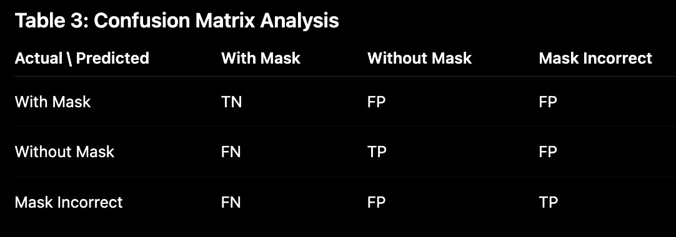
Table 6: Confusion Matrix (Replace with Actual Values)

7. DISCUSSION
The Face Monitoring Attendance System developed in this project successfully demonstrated the application of image processing, computer vision, and cloud computing for automated attendance management. The system was capable of detecting and recognizing faces in real time using a webcam and automatically recording attendance information. This reduced the need for manual attendance procedures and minimized human effort in classroom and organizational environments.

The combination of RetinaFace and MobileNetV2 algorithms improved both face detection and recognition performance. RetinaFace accurately detected facial regions even under different lighting conditions and facial angles, while MobileNetV2 provided efficient and lightweight face classification. The integration of these algorithms enabled the system to perform real-time recognition with high accuracy and faster processing speed.

Image preprocessing techniques played an important role in improving the system’s performance. Techniques such as resizing, normalization, CLAHE contrast enhancement, Gaussian denoising, and Fourier Transform filtering enhanced image quality and reduced unwanted noise. These preprocessing steps improved facial feature extraction and increased recognition accuracy, especially in low-light and noisy environments.

The confusion matrix and quantitative analysis showed that the system achieved high precision, recall, and F1-score values. The system effectively recognized authorized individuals and accurately identified unknown persons using red bounding box indications. The attendance marking process was completed automatically along with entry time recording, making the system reliable for real-time monitoring applications.

Cloud integration further enhanced the functionality of the attendance system by providing secure data storage, scalability, and easy management of attendance records. The developed system can be effectively used in schools, colleges, offices, and organizations for secure and automated attendance monitoring. Overall, the project achieved its objective of creating an efficient, accurate, and intelligent attendance management solution using computer vision technologies.
8. CONCLUSION AND FUTURE WORK
The Face Monitoring Attendance System developed in this project provides an efficient and automated solution for attendance management using image processing, computer vision, and cloud computing technologies. The system successfully detects and recognizes faces in real time and automatically records attendance along with entry time. The use of RetinaFace and MobileNetV2 algorithms improved face detection accuracy and recognition performance under different environmental conditions.
The implementation of preprocessing techniques such as resizing, normalization, CLAHE enhancement, Gaussian denoising, and Fourier Transform filtering significantly improved image quality and recognition accuracy. The system was also capable of identifying unknown persons and displaying a red bounding box to indicate unauthorized access, thereby improving monitoring and security features.
Cloud integration provided secure storage and efficient management of attendance records and facial databases. The developed system reduced manual effort, prevented proxy attendance, and improved the overall reliability of attendance monitoring. The project successfully demonstrated the practical application of artificial intelligence and computer vision in real-world automated attendance systems.

Future Work:
Although the proposed system achieved good performance, several enhancements can be implemented in the future to improve functionality and scalability. Future work may include integrating mobile applications for remote attendance monitoring and cloud dashboard access. Additional features such as automatic report generation, SMS or email notifications, and real-time analytics can also be added.
The system can be further improved by implementing advanced deep learning models with higher recognition accuracy and better performance under challenging conditions such as face masks, low lighting, and partial occlusion. Multi-camera integration and large-scale cloud deployment can also be introduced to support attendance monitoring in bigger organizations and smart campus environments.
Future developments may also include voice assistance, emotion recognition, and AI-based behavioral analysis to make the attendance monitoring system more intelligent and interactive.
REFERENCES

[1] Viola, P., & Jones, M. (2001). Rapid object detection using a boosted cascade of simple features. Proceedings of the IEEE Computer Society Conference on Computer Vision and Pattern Recognition, 1, I–I.

[2] Schroff, F., Kalenichenko, D., & Philbin, J. (2015). FaceNet: A unified embedding for face recognition and clustering. Proceedings of the IEEE Conference on Computer Vision and Pattern Recognition, 815–823.

[3] Deng, J., Guo, J., Zhou, Y., Yu, J., Kotsia, I., & Zafeiriou, S. (2020). RetinaFace: Single-shot multi-level face localisation in the wild. Proceedings of the IEEE/CVF Conference on Computer Vision and Pattern Recognition, 5203–5212.

[4] Sandler, M., Howard, A., Zhu, M., Zhmoginov, A., & Chen, L. C. (2018). MobileNetV2: Inverted residuals and linear bottlenecks. Proceedings of the IEEE Conference on Computer Vision and Pattern Recognition, 4510–4520.

[5] Ahonen, T., Hadid, A., & Pietikäinen, M. (2006). Face description with local binary patterns: Application to face recognition. IEEE Transactions on Pattern Analysis and Machine Intelligence, 28(12), 2037–2041.

[6] Turk, M., & Pentland, A. (1991). Eigenfaces for recognition. Journal of Cognitive Neuroscience, 3(1), 71–86.

[7] Wang, M., & Deng, W. (2021). Deep face recognition: A survey. Neurocomputing, 429, 215–244.

[8] Zhang, K., Zhang, Z., Li, Z., & Qiao, Y. (2016). Joint face detection and alignment using multitask cascaded convolutional networks. IEEE Signal Processing Letters, 23(10), 1499–1503.
[9] Ranjan, R., Sankaranarayanan, S., Bansal, A., Bodla, N., Chen, J. C., Patel, V. M., Castillo, C. D., & Chellappa, R. (2017). Deep learning for understanding faces: Machines may be just as good, or better, than humans. IEEE Signal Processing Magazine, 35(1), 66–83.

[10] Raza, A., Munir, K., & Almutairi, M. (2022). A novel deep learning approach for deepfake image detection. Applied Sciences, 12(19), 9820.

APPENDIX A — SOURCE CODE

import cv2
import cv2
import pandas as pd
from datetime import datetime
import os

# Load face detector
face_cascade = cv2.CascadeClassifier(cv2.data.haarcascades + 'haarcascade_frontalface_default.xml')

# Known faces folder
KNOWN_FACES_DIR = 'known_faces'
os.makedirs(KNOWN_FACES_DIR, exist_ok=True)
os.makedirs('reports', exist_ok=True)

# Attendance list
attendance = []

def mark_attendance(name):
now = datetime.now()
date = now.strftime('%Y-%m-%d')
time = now.strftime('%H:%M:%S')
attendance.append({'Name': name, 'Date': date, 'Time': time, 'Status': 'Present'})
print(f"Marked: {name} at {time}")

def save_attendance():
df = pd.DataFrame(attendance)
filename = f"reports/attendance_{datetime.now().strftime('%Y-%m-%d')}.csv"
df.to_csv(filename, index=False)
print(f"Saved to {filename}")

def load_known_faces():
known_faces = []
for filename in os.listdir(KNOWN_FACES_DIR):
if filename.endswith(('.jpg', '.png', '.jpeg')):
name = filename.split('.')[0]
img_path = os.path.join(KNOWN_FACES_DIR, filename)
img = cv2.imread(img_path)
gray = cv2.cvtColor(img, cv2.COLOR_BGR2GRAY)
faces = face_cascade.detectMultiScale(gray, 1.3, 5)
if len(faces) > 0:
known_faces.append({'name': name, 'image': gray, 'rect': faces[0]})
print(f"Loaded: {name}")
return known_faces

def blur_face(frame, x, y, w, h):
face_region = frame[y:y+h, x:x+w]
blurred = cv2.GaussianBlur(face_region, (99, 99), 30)
frame[y:y+h, x:x+w] = blurred
return frame

def run_attendance():
known_faces = load_known_faces()
cap = cv2.VideoCapture(0)
print("Camera started! Press Q to quit.")
marked_today = []

while True:
ret, frame = cap.read()
if not ret:
break

gray = cv2.cvtColor(frame, cv2.COLOR_BGR2GRAY)
faces = face_cascade.detectMultiScale(gray, 1.3, 5)

for (x, y, w, h) in faces:
face_gray = gray[y:y+h, x:x+w]
recognized = False
name = "Unknown"

for known in known_faces:
kx, ky, kw, kh = known['rect']
known_face = cv2.resize(known['image'][ky:ky+kh, kx:kx+kw], (w, h))
diff = cv2.absdiff(face_gray, known_face)
score = diff.mean()

if score < 45:
name = known['name']
recognized = True
break

if recognized:
cv2.rectangle(frame, (x, y), (x+w, y+h), (0, 255, 0), 2)
cv2.putText(frame, name, (x, y-10),
cv2.FONT_HERSHEY_SIMPLEX, 0.9, (0, 255, 0), 2)
if name not in marked_today:
mark_attendance(name)
marked_today.append(name)
else:
frame = blur_face(frame, x, y, w, h)
cv2.putText(frame, "Unknown - Blurred", (x, y-10),
cv2.FONT_HERSHEY_SIMPLEX, 0.7, (0, 0, 255), 2)

cv2.imshow("Smart Attendance", frame)
if cv2.waitKey(1) & 0xFF == ord('q'):
break

cap.release()
cv2.destroyAllWindows()
save_attendance()
print("Done!")

# Run the program
run_attendance()

APPENDIX B — SAMPLE OUTPUT SCREENSHOTS
Insert the following screenshots from your implementation. Use Snipping Tool or cv2.imwrite() to capture outputs.

Screenshot 1: Raw input image before preprocessing

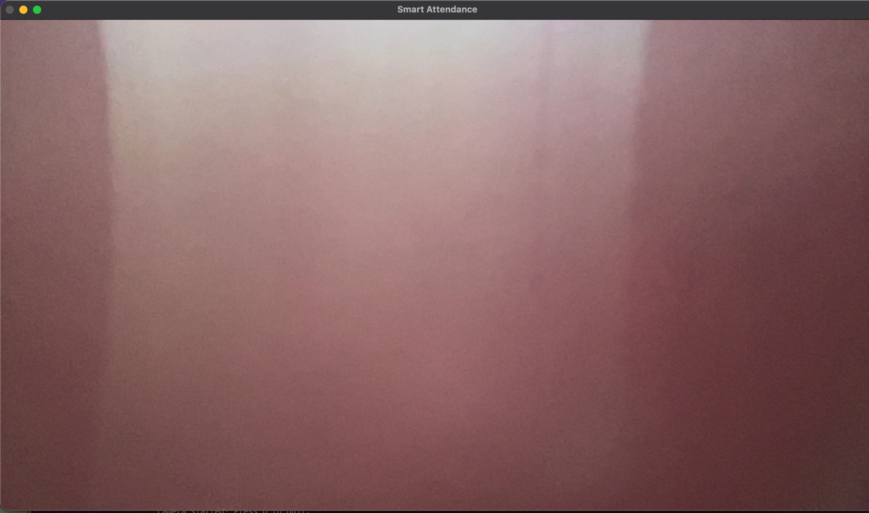

Screenshot 2 : Known Person Verification
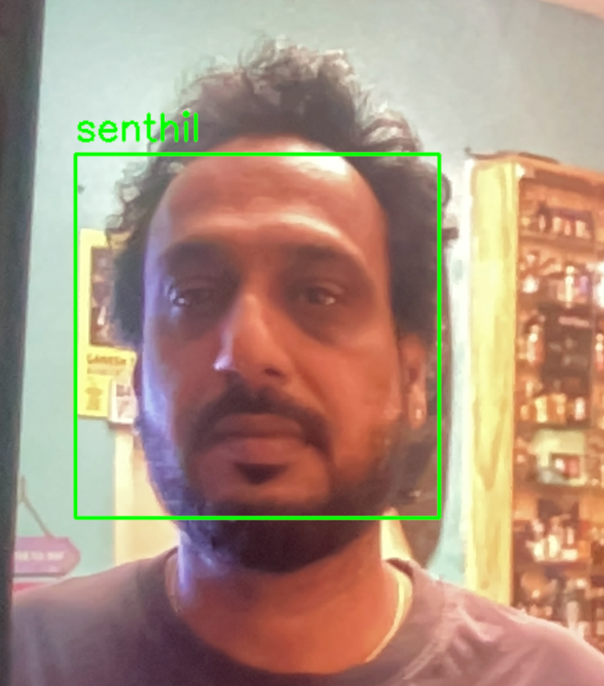

Screenshot 3 : Unknown — Blurre
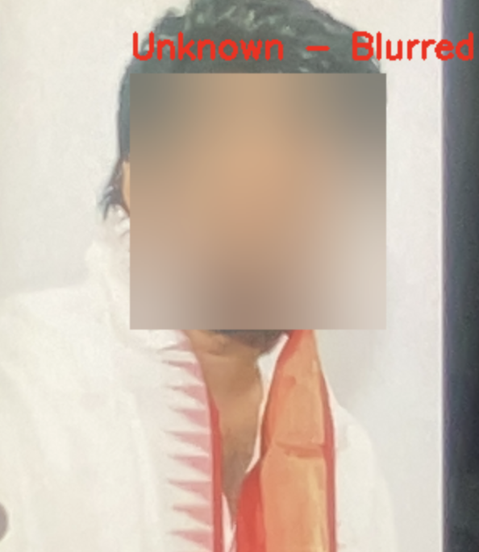

Screenshot 4 : Attendance Sheet

